**AIR QUALITY MONITORING USING IOT**

# TEAM MEMBER

**511821106001:AHMED SHARIFF A**

PHASE 2 PROJECT

Name of the project:

AIR QUALITIY MONITORING

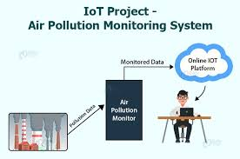

INTRODUCTION:

Air quality monitoring refers to continuous measurement of specific air pollutants also known as “criteria air pollutants”. Obtained air pollution data together with natural background/trace gas monitoring and stationary source emission monitoring helps to define what kind of air pollution people are exposed to.

OBJECTIVE:

The main objective of these Networks is to record the concentration levels of atmospheric pollutants in order to define air quality levels and establish action plans if high levels of contamination are detected. Other objectives are: Locating contamination problem areas and understanding their space- time changes.

COMPONENTS:

Air quality monitoring in IoT (Internet of Things) systems involves the use of various components to measure and assess the quality of the air in a particular environment. These components work together to collect and transmit data to a central system for analysis and decision-making.

key components of an IoT-based air quality monitoring system:

* Sensors:
* Particulate Matter (PM) Sensors: These sensors measure the concentration of fine particles or dust in the air, typically categorized into PM2.5 and PM10 to gauge air pollution.
* Gas Sensors: These sensors detect various gases such as carbon dioxide (CO2), carbon monoxide (CO), nitrogen dioxide (NO2), sulfur dioxide (SO2), ozone (O3), and volatile organic compounds (VOCs).
* Temperature and Humidity Sensors: Monitoring temperature and humidity levels is crucial for understanding how environmental conditions affect air quality.
* Microcontrollers or Processors:
* Microcontrollers like Arduino, Raspberry Pi, or specialized IoT platforms process the data from the sensors and can send it to a central server or display it locally.
* Communication Modules:
* Wi-Fi, cellular, LoRa (Long Range), or other wireless communication modules enable the transfer of data from the IoT device to a central server or cloud-based platform.
* Power Supply:
* Depending on the deployment location, power sources may include batteries, solar panels, or a combination of power options to ensure continuous operation.
* Data Processing and Storage:
* Central servers or cloud platforms receive, process, and store the data from multiple IoT devices. This data can be analyzed and made accessible to users through web applications or APIs.
* User Interface:
* Web or mobile applications provide real-time and historical air quality data, allowing users to monitor air quality and receive alerts or notifications when levels are unhealthy.
* Alerts and Notifications:
* Algorithms can be implemented to trigger alerts or notifications when air quality levels reach predefined thresholds. These alerts can be sent to users or relevant authorities.

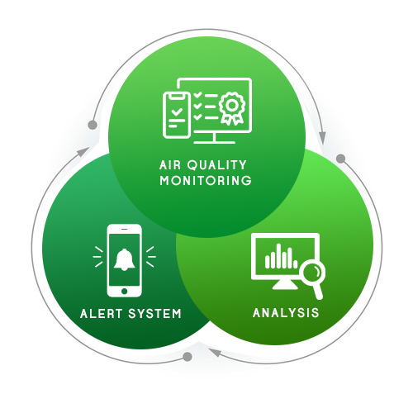

WORKING:

Air quality monitoring in the context of the Internet of Things (IoT) is a critical application that involves the use of sensors and connected devices to collect and analyze data related to air quality. This technology has numerous environmental and health-related benefits, as it enables real-time monitoring and data-driven decision-making. Here's how it works:

* Sensors:
* IoT air quality monitoring systems typically use various types of sensors to measure different air quality parameters. These sensors can include:
* Particulate Matter (PM) Sensors: These measure the concentration of tiny particles in the air, such as PM2.5 and PM10, which are associated with respiratory problems.
* Gas Sensors:
* These detect the levels of gases like carbon dioxide (CO2), carbon monoxide (CO), nitrogen dioxide (NO2), sulfur dioxide (SO2), and ozone (O3), which are key indicators of air quality.
* Meteorological Sensors:
* These collect data on temperature, humidity, wind speed, and direction, which can influence air quality.

Data Collection:

* Sensors collect data at regular intervals, and this data is then transmitted to a central system or the cloud through wireless communication protocols like Wi-Fi, cellular, LoRa, or NB-IoT.

Data Processing:

* In the central system or the cloud, the data is processed, aggregated, and analyzed. This involves calculating various air quality indices and identifying potential pollutants or issues.

Data Visualization:

* Processed data is often visualized using dashboards or web interfaces. Users, such as environmental agencies, city planners, or the general public, can access this information to check the current air quality in their area.

Alerts and Notifications:

* When air quality deteriorates beyond predefined thresholds, the system can send alerts and notifications to relevant stakeholders, allowing them to take appropriate actions.

Historical Data and Trend Analysis:

* IoT systems also store historical data, which can be used for trend analysis and research. This information is valuable for identifying long-term patterns and making informed decisions about environmental policies and interventions.

Integration:

* Air quality monitoring systems can be integrated with other IoT applications, such as traffic management, to reduce pollution in congested areas. They can also be linked to weather forecasting to predict air quality changes.

Regulatory Compliance:

* Many regions have specific air quality regulations. IoT air quality monitoring systems can help organizations and governments comply with these regulations by providing accurate and up-to-date data.

Public Engagement:

* Making air quality data easily accessible to the public can raise awareness and encourage citizens to take steps to improve air quality, such as reducing vehicle emissions or avoiding outdoor activities on poor air quality days.